# 2.1 INTRODUCTION

In this section literature relevant to the topic are reviewed. These include scholarly works like papers, articles and reports. They are looked through to provide clarity and further highlight the topic at hand.

# 2.2 RELATED WORK

The creation of the first mainstream blockchain was inspired by the libertarian idea of two individuals being free to transact with one another without the need for a centralized intermediary. This is evident in the whitepaper published by Satoshi Nakamoto a year before the release of bitcoin. In the paper, Nakamoto (2008) speaks of how peer-to-peer electronic cash systems that aren’t backed by any centralized entity could be implemented with use of digital signatures. They also pointed out in the whitepaper that the purpose of such a system would be defeated if a third party were trusted to handle double spending. The proposed solution was a peer-to-peer network which linked timed stamped hashed into a chain. The longest chain in the system served as proof that an event was validated by the proof of work pool with the most processing power. This system would work as long as no one controlled the outright majority of processing power on the network.

Nakamoto’s paper shared an interesting vision on the future of finance and could be seen as stemming from distrust in the powers that be seeing as it was published during the financial crisis. The idea of a decentralized network with mechanisms that verify the occurrence of an event does make sense.

The work that formed the basis for Bitcoin came over a decade earlier (Haber & Stornetta, 1991). It was motivated by the increasing prevalence of digital documentation and with it the need to verify when the document was modified or created. It was determined that an unchangeable timestamp was to be used. The timestamps were implemented using cryptographic hash functions. This was handled in two ways. In the first way document hashes are linked together and certificates recording the linking would be sent to clients accessing the document later on. In the second, a pool of clients time stamp a hash. Both approaches bear similarity to how a modern blockchains work and were seemingly adapted into their design.

The novelty of blockchain systems make the ideal for a number of application areas. One of these areas is the management of land as highlighted by Crumpler, W., Flacks, M., & Mandavilli, A. (2021). They highlight how beneficial blockchain could be in the managing of land. The authors further go on to highlight the how essential of a right access to land is. That it will become even more valuable as the world’s population growths even larger. They further highlight the challenges faced in the management of land. These are the inadequate allocation of land, especially to women. There is also the prioritization of individual ownership of land and neglect of communal land ownership.

The authors further highlight how blockchain can be implemented to complement existing systems by placing existing records in a centralized database. These would have time stamped hashes that are logged and public facing records are managed by government agency. Another approach brought forward is to store land titles as tokens using metadata.

For all the benefits the use of blockchain offers in the management of land it isn’t a silver bullet that alleviates all the problems experienced. The authors point out the fact that blockchain may reinforce even distribution of land and that, on its own, it doesn’t make the transition from informal to formal record keeping any easier.

The need to have a more standardized land tenure system has been recognized by many African governments. According to Chimhowu (2019), over the last couple of decades there has been a change in the way customary land is administered. Customary land is usually owned by traditional leadership structures and individuals usually have a stake in it by being born of the same ethnic group. The author alludes to a more neo liberal approach taking root as now an individual can claim rights to customary land without as long as they can pay for it. These changes have driven by a number of deliberate reforms implemented to customary land tenure. According to the first has been the privatization of customary land. This involved the making it easier for individuals to own land. This has been implemented in a number of African countries. It is complemented by the registration of customary land users and surveying of land boundaries. There has also been marketization of customary land. Even though there is no standard pricing for customary land its registration has created a market for it. Deregulation was also pursued. This involved the removal of legal barriers that made the trade of land as a commodity. This enabled the issuance of third-party leases. Lastly, there was reregulation. Not was customary land tenure recognized but it was also standardized and incorporated into normal tenure policies. This has clearly shown a desire to fully recognize all common forms of land tenure which can be further enhanced with the use of modern technology.

Attempts to enhance or recognize customary land tenure don’t always yield benefits for all involved. There are aspects of customary land tenure that aren’t captured in reforms aimed at formalizing it (Zuka, 2019). Customary land agreements may not be ideals but are expounded by neo liberal approaches instead of expanding on the key aspects of customary land tenure. In many traditional settings not all are represented equally in customary land tenure and women suffer the most from land grabbing. This is evident when secondary land rights come into play. These are accorded to women patrilineal marital arrangement. The reforms don’t guarantee the rights to customary land by those who succeed a deceased person according to the study carried out. They don’t recognize customary land tenure embedded in marital practices and lineal traditions.

# 2.3 SIMILAR SYSTEMS

## THE DUBAI LAND REGISTRY

The government of Dubai saw the potential for blockchain and had a blockchain based Land registry implemented (“Dubai Land Department achieves”, 2017). The system developed by the Dubai Land Department holds all real estate contracts, including leases, in Dubai. The system integrates with the databases of different public utilities like the Dubai Electricity and Water Authority which enables the system to also track billing. It’s also linked to citizen and resident information enabling them to carry out transactions through the system from anywhere. The system can be accessed through any web browser.

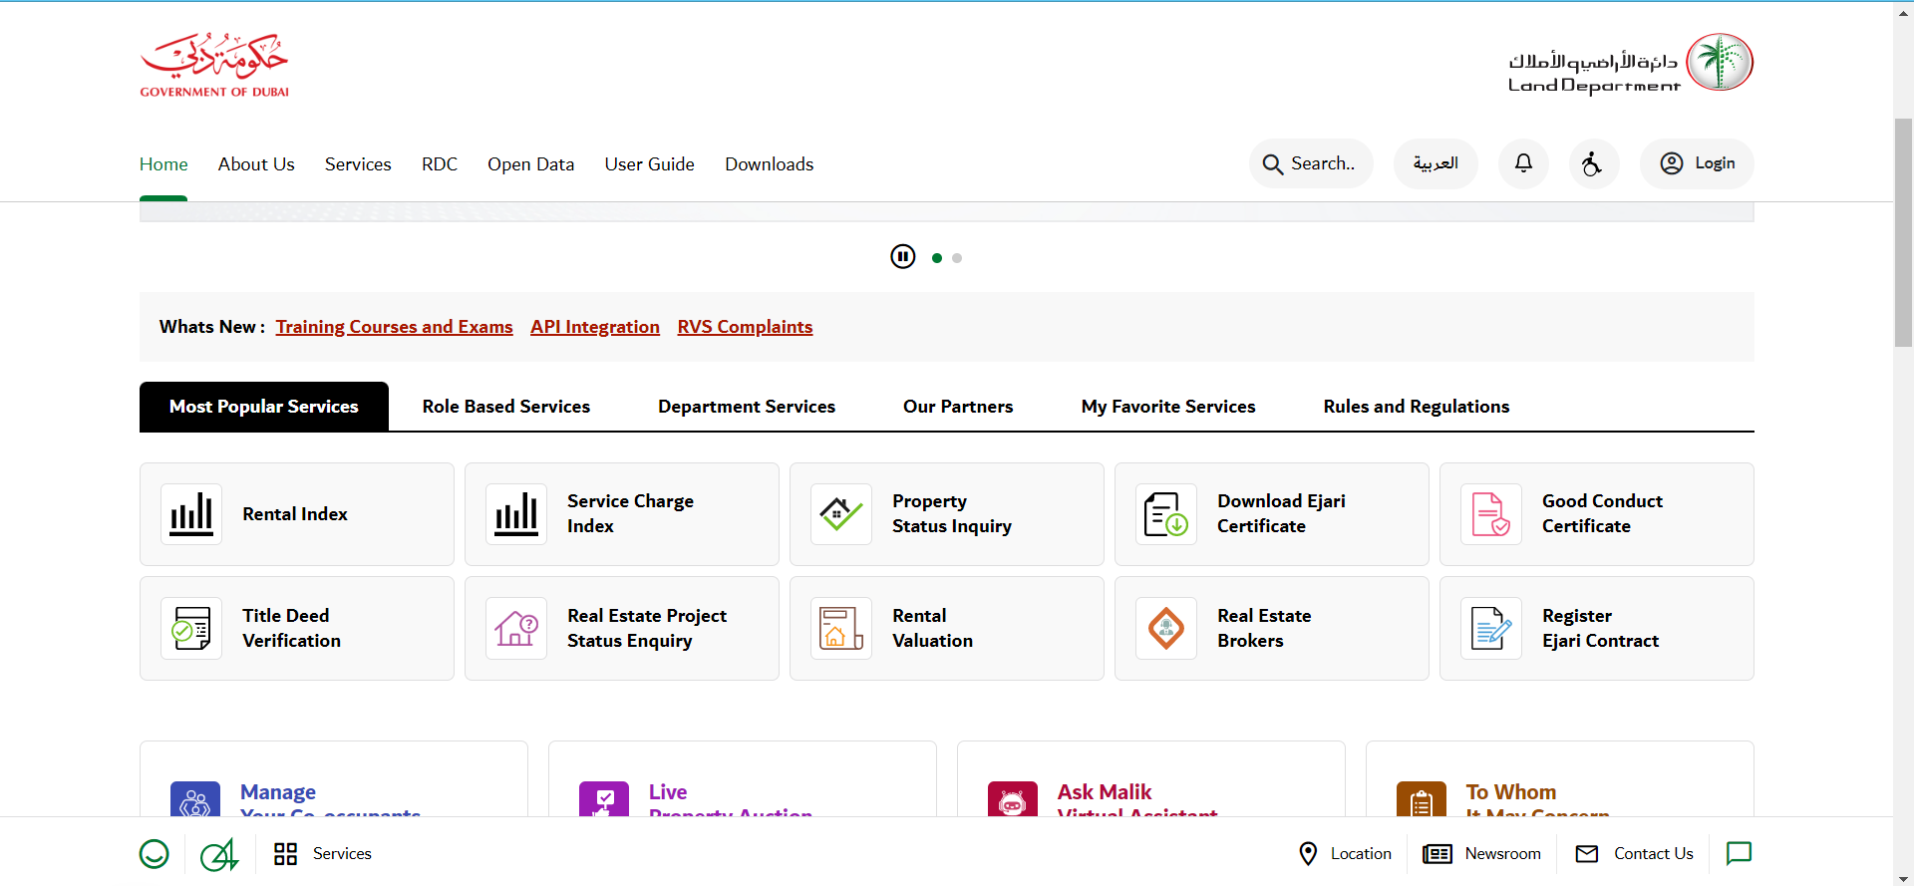

# THE LAND ASSET MANAGEMENT SYSTEM

This is a dedicated enterprise level software that is meant to manage all land acquisition. It is also meant to aid the allotment of land and to consolidate all information concerning land management in a single window. It is web and mobile based. The system serves as a central repository for all land information. It allows plot visualization, land acquisition process monitoring and plot valuation. The system is meant for use by government and commercial entities.

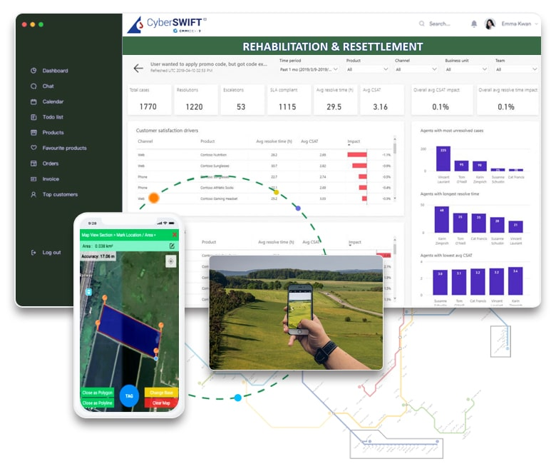

# 2.4 LESSONS LEARNT

One major lesson taken away from the review is that it is important to take into consideration the interests of all the parties involved in the development of a system. What may seem as an improvement on the current way of doing things might actually continue to disadvantage certain parties.

# 2.5. CRITIQUE OF REVIEW

## THE DUBAI LAND REGISTRY

The system is very feature rich and makes use of a relatively new technology. Residents are able to apply for land, view land that is currently available and view valuation details. It also has many integrations making for a great data collection and comprehensive information about a property. However, this plethora of features can make for a somewhat cluttered design. The many integrations require more maintenance like bug fixes.

## THE LAND ASSET MANAGEMENT SYSTEM

The system appears to be applicable in many setting where land administration is needed. It allows a user to view information about all the land under their administration. It is a good solution for entities looking for a somewhat generic ready-made solution for their land administration needs. Unfortunately, in more complex settings with different communities involved it may not be the best solution or may require further modification which could involve more costs.

# 2.6 CONCLUSION

This section dealt with the review of related developments and work. The next section will involve the outlining of the methodology to be used and the determining the functionality of the system.